Quiz-1 prep

* Question solve of quiz of 19
* Solve question of chapter 5 from tcp/ip
* Solve subnetting question of ccna
* Read chapter 6 of tcp/ip
* Read chapter 7 tcp/ip

All the best elmo you need to do best! 😛 🙂

Quiz 2 -(19)solve (as it matches with the content of our first quiz)

Set 1_B

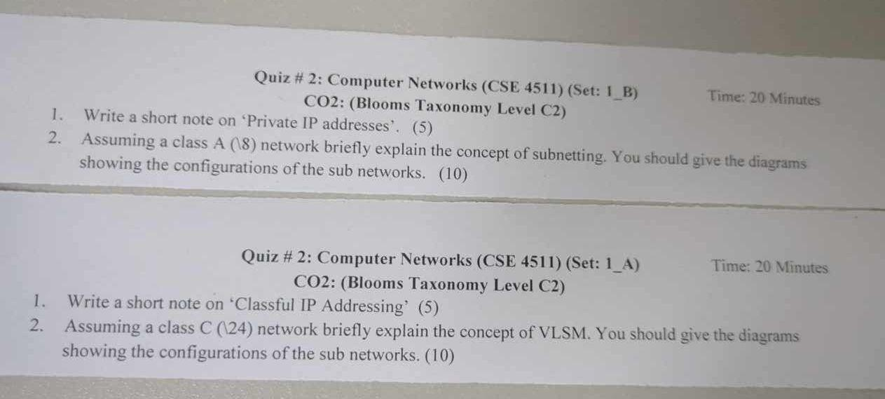

1. Short note in private ip addresses(from tcp,ccna and chatgpt)

A number of blocks are assigned for private use.they are not recognized globally.Private addresses can be used on a private network but they're not routable through the internet.this is designed for the purpose of creating a measure of well needed security, but it also conveniently saves valuable address space.To accomplish this, the end user need to use NAT )network address translation).private addresses provides a pool of addresses that can be used within local networks and NAT is a technique that allows these devices to access the public internet using a shared public IP address.NAT ensures that communication between the private network and the public internet is possible by translating IP addresses in both outgoing and ingoing data packets.

Thn will provide the range of private address

Class A- 10.0.0.0 through 10.255.255.255

Class B-172.16.00 through 172.31.255.255

Class c-192.168.0.0 through 198.168.255.255

2.

Subnetting is the process of dividing a larger IP network into smaller, more manageable subnetworks or subnets. This is achieved by borrowing bits from the host portion of the ip address to create additional network identifiers,allowing for better organization , improved efficiency and enhanced security within a network.for class A(\8) lets take an example of 10.0.0.0/8 subnetting into 4 small networks

For 4 smol network we will need to borrow 2 bit from the host then when we borrowing its 10.0.0.0(\10)

255.192.0.0(\10)

No of subnets -2^2=4

Host per subnet→ 2^26-2

Valid subnet→ 256-192=64 (for the second octet)

Frm chatgpt

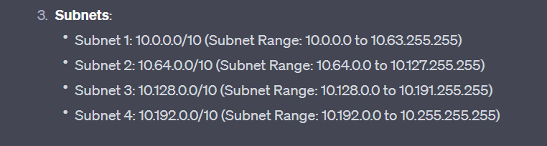

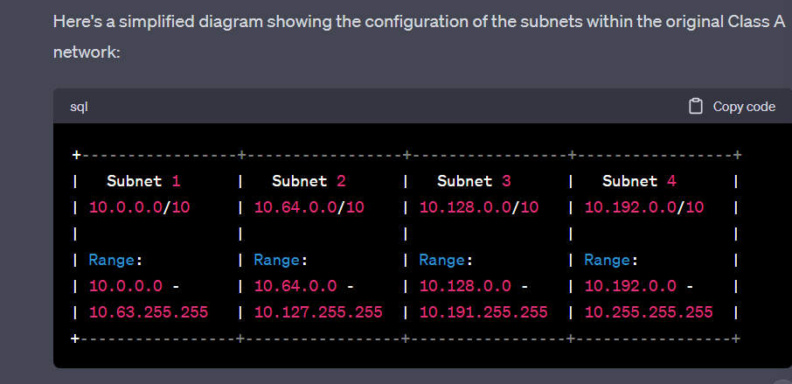

We will do the table method to show this

From Ashnan bhais solution -

Class A

Broadcast address subnets

255.0.0.0 \8

255.128.0.0 \9

255.192.0.0 \10

255.224.0.0 \11

255.240.0.0 \12

255.248.0.0 \13

255.252.0.0 \14

255.254.0.0 \15

255.255.0.0 \16

|

|

|

255.255.255.252(\30) \30

